**Project Design Phase-II**

**Data Flow Diagram & User Stories**

|  |  |
| --- | --- |
| Date | 03 October 2022 |
| Team ID | PNT2022TMID51719 |
| Project Name | Smart Farming-IOT Enabled smart farming application |
| Maximum Marks | 4 Marks |

**Data Flow Diagrams:**

A data flow diagram (DFD) maps out the flow of information for any process or system. It uses defined symbols like rectangles, circles and arrows, plus short text labels, to show data inputs, outputs, storage points and the routes between each destination. Data flowcharts can range from simple, even hand-drawn process overviews, to in-depth, multi-level DFDs that dig progressively deeper into how the data is handled. They can be used to analyze an existing system or model a new one. That’s why DFDs remain so popular after all these years. While they work well for data flow software and systems, they are less applicable nowadays to visualizing interactive, real-time or database-oriented software or systems.

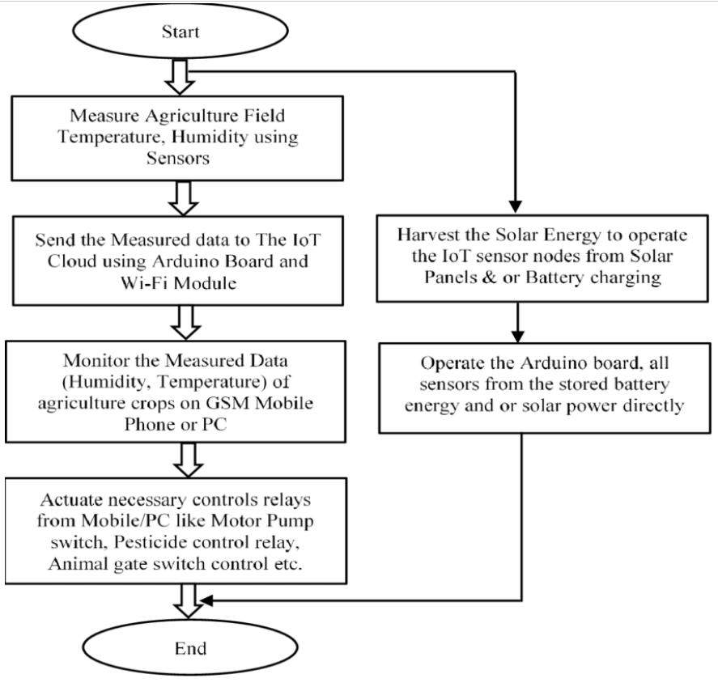

**FLOW**

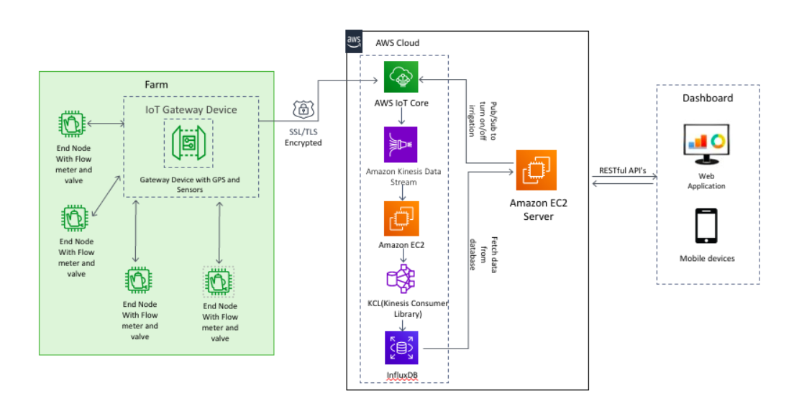

**User Stories**

| **User Type** | **Functional Requirement (Epic)** | **User Story Number** | **User Story / Task** | **Priority** |
| --- | --- | --- | --- | --- |
| Farmer(Mobile user) | Registration | USN-1 | As a user, I can register for the application by entering my email, password, and confirming my password. | High |
|  |  | USN-2 | As a user, I will receive confirmation email once I have registered for the application | High |
|  | Login | USN-3 | As a user, I can log into the application by entering email & password | High |
|  | Dashboard | USN-4 | As a user, I can able to learn how to access the application. | High |
| Farmer(Gadget User) | Monitoring of climatic condition | USN-1 | As a user, I can use gadgets which are weather stations, combining various smart farming sensors measurements can be used to map the climate conditions. | High |
|  | Agricultural drones | USN-2 | Agritech advancements is the use of agricultural drones in smart farming. drones are better equipped than airplanes and satellites to collect agricultural data. Apart from surveillance capabilities, drones can also perform a vast number of tasks that previously required human labor : planting crops, fighting pests and infections, agriculture spraying, crop monitoring, etc. | Medium |
| Farmers | Greenhouse automation | USN-1 | Farmers use manual intervention to control the greenhouse environment. The use of IOT sensors enables them to get accurate real-time information on greenhouse conditions such as lighting, temperature, soil condition, and humidity. | High |
| Farmers | Crop management | USN-2 | Weather stations, user should be specific to placed in the field to collect data crop farming; from temperature and precipitation to leaf water potential and overall crop health. | Medium |
|  | Cattle monitoring and management | USN-3 | IOT agriculture sensors that can be attached to the animals on a farm to monitor their health and log performance. Livestock tracking and monitoring help collect data on stock health, well-being, and physical location. | Medium |
|  | Precision farming | USN-4 | Farmers can collect a vast array of metrics on every facet of the field microclimate and ecosystem: lighting, temperature, soil condition, humidity, CO2 levels, and pest infections. This data enables farmers to estimate optimal amounts of water, fertilizers, and pesticides that their crops need, reduce expenses, and raise better and healthier crops. | High |
|  | Predictive analytics | USN-5 | The use of data analytics helps farmers make sense of it and come up with important predictions: crop harvesting time, the risks of diseases and infestations, yield volume, etc. Data analytics tools help make farming, which is inherently highly dependent on weather conditions, more manageable, and predictable. | Medium |
|  | End-to-end farm management systems | USN-6 | Number of agriculture IOT devices and sensors, installed on the premises as well as a powerful dashboard with analytical capabilities and in-built accounting/reporting features. | Medium |